Exercise 3: Vector & Raster Data

Jatin Chowdhary

Lab Section #03

Wednesday, November 1st, 2017

Michele Tsang

1. The coordinate system of the data frame is: NAD_1983_UTM_Zone_17N

2. If the layer, Census Tracts, was added first to the data frame, then the coordinate system would have been: GCS_North_American_1983. This is because ArcMap uses the first layer’s coordinate system when setting the data frame’s coordinate system.

3. Without using the shift key, you can use: Select By Polygon, Select By Lasso, Select By Line

4. There are 15 census tracts within Ward 8's boundary

5.

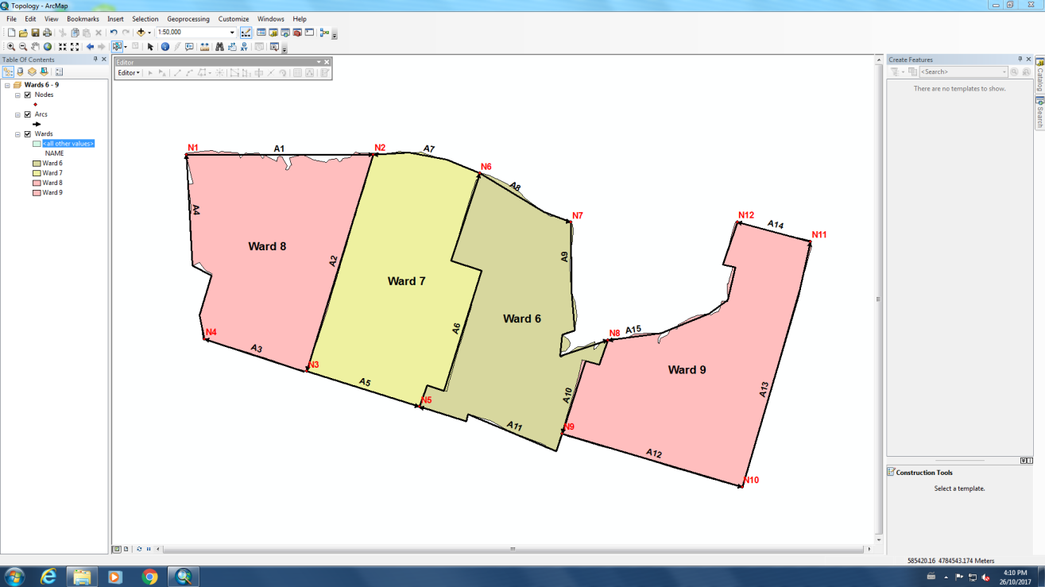

6.

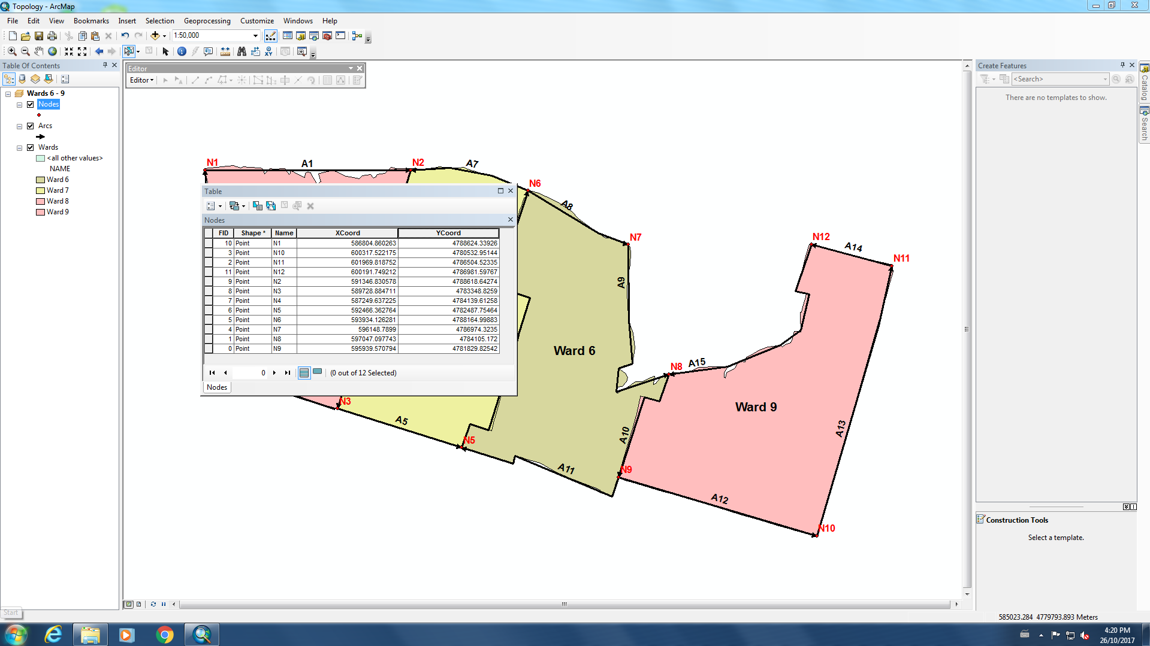

7.

|  |  |  |  |  |
| --- | --- | --- | --- | --- |
| **ARC** | **FNODE** | **TNODE** | **LPOLY** | **RPOLY** |
| 1 | 1 | 2 | 0 | 1 |
| 2 | 2 | 3 | 2 | 1 |
| 3 | 3 | 4 | 0 | 1 |
| 4 | 4 | 1 | 0 | 1 |
| 5 | 3 | 5 | 2 | 0 |
| 6 | 5 | 6 | 2 | 3 |
| 7 | 6 | 2 | 2 | 0 |
| 8 | 6 | 7 | 0 | 3 |
| 9 | 7 | 8 | 0 | 3 |
| 10 | 8 | 9 | 4 | 3 |
| 11 | 9 | 5 | 0 | 3 |
| 12 | 9 | 10 | 4 | 0 |
| 13 | 10 | 11 | 4 | 0 |
| 14 | 11 | 12 | 4 | 0 |
| 15 | 12 | 8 | 4 | 0 |

|  |  |
| --- | --- |
| **POLY** | **ARCS** |
| 1 (Ward 8) | 1, 2, 3, 4 |
| 2 (Ward 7) | 2, 5, 6, 7 |
| 3 (Ward 6) | 6, 8, 9, 10, 11 |
| 4 (Ward 9) | 10, 12, 13, 14, 15 |

8. The system defaults to using the coordinate system of the data frame because different coordinate systems have different projections and distortions, leading to different calculations when it comes to area. Hence, the system uses the data frame’s CS to calculate area.

9.

|  |  |  |
| --- | --- | --- |
| 5 | 5 | 6 |
| 5 | 4 | 4 |
| 5 | 5 | 4 |

10. The resulting raster is not accurate because it omits a lot of important information. For instance, there are 7 different land uses inside "SampleArea" and the raster only reveals 3. The cell-center approach focuses on the center of the cell, while ignoring surrounding features and other variables like (total) area. Furthermore, sometimes a cell is dominated by one feature, but isn’t represented because it isn’t the center of the cell. Also, the cell-center approach completely omits smaller features, and the raster ends up representing the most prominent feature or the one in the center.

11.

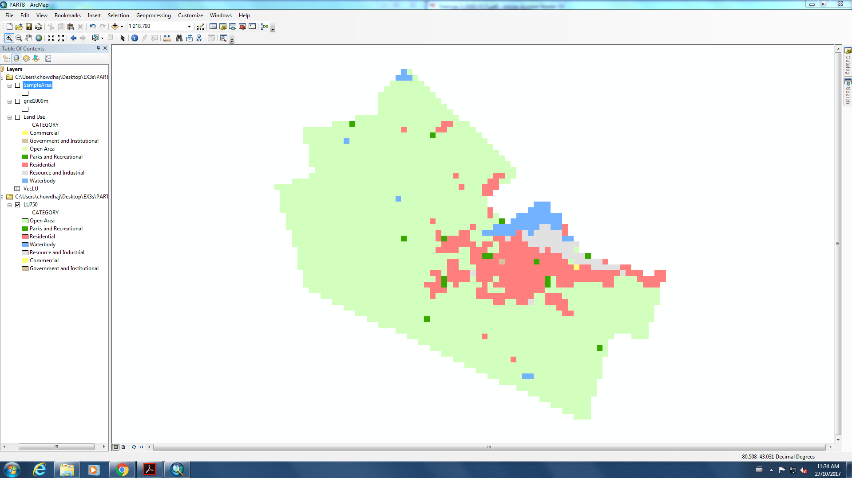

12.

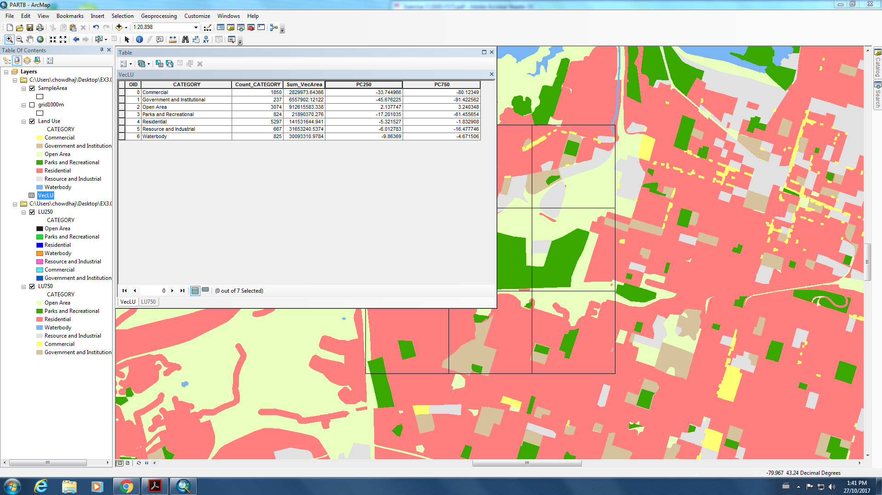

13. The absolute percent difference for LU250 is (generally) less than LU750, making LU250 a more accurate raster. LU250 does a better job at representing features – especially smaller features – than LU750. LU750 is fine at representing large features (i.e. Open Area), but struggles with smaller features (i.e. Commercial). On the other hand, LU250 can represent large and small features more accurately than LU750. See table below.

